Business Rates and Faith Buildings

Briefing Note

1. Aim of this Paper

This briefing note seeks to provide guidance to people running faith-based buildings about the position of these buildings with regard to business rates. It outlines the rating status of buildings that are places of public worship, and discusses the position where organisations are charities. This guidance aims to help groups avail themselves of any of the rating concessions to which they may be entitled.

Please note that this is a very complex area, where different interpretations of the law are possible, so whilst this guidance has been prepared with care you are strongly advised to check all matters related to your particular organisation/premises with the relevant bodies before taking (or failing to take) any action.

‘Business rates’ are also called ‘Non-domestic rates’, but the term Business rates will be used in this paper as this is the term that is most commonly used.

2. Why you should read this Guidance

- It may save your organisation money, at a time when most budgets are being squeezed.

- If your organisation is a charity getting Discretionary Rates Relief (DRR) you may be asked to pay more in the near future under proposed changes to DRR and you need to understand what might happen, and plan for this (see S.3. for an explanation of DRR.)

3. Relief from Rates for Charities

Many faith organisations are registered charities, which means that they can obtain valuable concessions on the rates due on their buildings. There are two levels of rate relief:

- Mandatory relief (i.e. a concession which must be given by law.) - Charities in occupation of a property are entitled to 80% mandatory relief from their rates bill, providing the property is used wholly or mainly for charitable purposes. This relief is at 80% of the rates charged and will continue from year to year, or until such time the property ceases to be used for charitable purposes.

- Discretionary relief – Local authorities can choose to award a further 20% rates relief to a charity, meaning that the charity does not have to pay any business rates. Islington Council award this relief according to the following criteria which prioritise:

- Organisations whose activities are primarily for the benefit of residents of the boroughs
- Organisations serving the needs of socially excluded and marginalised sections of the community.
- Local organisations managed by people who live in the borough
- Organisations that encourage and recruit volunteers in order to carry out their activities
- Self-help groups that are not able to attract funding in order to carry out their actives
- Organisations that relieve the council from providing certain facilities

To date, once this discretionary relief was awarded by Islington Council it would generally continue so long as the property continued to be used for charitable purposes. However, this policy is under review.

This relief is available under the Local Government Finance Act 1988. Unlike exempt properties which are not included in the Valuation List, properties where relief is being given are included as they are potentially liable for rates, although relief is being given.

Note - An organisation which is not a registered charity but has charitable objectives may be eligible for rates relief. Documentary evidence such as the memorandum and articles of association showing that the main objectives are charitable must be produced to support such applications.

Information on how to apply to the London Borough of Islington for discretionary relief is provided at the end of this paper in Section 8.2.

Changes to the way DRR is awarded

Islington Council is reviewing how it awards this discretionary relief. Changes, including reviewing all discretionary rate relief awards annually were proposed in Islington’s ‘Community Fund Consultation’ late in 2010. The Council’s latest position is as follows:
- Organisations currently receiving Discretionary Rate Relief DRR will receive 12 month notice letters by 31st March 2011.
- A follow up report detailing criteria and application processes will be considered by the Voluntary and Community Sector Committee (VCS) in June. This is to ‘allow officers time to research alternative options and respond to the concerns raised in the consultation about annual reviews.’
- Decisions about Discretionary Rare Relief awards will be made by the VCS Committee in December and will be effective from 1st April 2012

LBI propose to make a total of £450,000 available each year for discretionary rate relief. Charities will have to apply afresh each year for this relief, with the possibility that current recipients could lose the relief so that it can be awarded to new charities.

This has led some organisations to explore whether there are other ways of minimising their liability to pay business rates, and consideration being given by those organisations where worship takes place on the premises to the possibility of seeking exemption from business rates.

4. Places of Public Worship and Exemption from Business Rates

Places of religious worship are exempt from Business rates (non-domestic rates,) as follows:

- Places of religious worship (where these belong to the Church of England) are exempt.

- For other religions, places of religious worship are exempt where the property is certified under the Places of Worship Registration Act 1855. (See S.5 for guidance on registration.)

(This distinction can be explained by the Church of England’s (CofE) historical position as England’s established church.)

The District Valuer does not include exempt properties in the Valuation List.

There are two key points to note:

- The worship must be public worship – if people who are not members of the religion are excluded, or only some members of a religion are admitted this will not be defines as public worship.

- The religious activity must be defined as worship – the activities of some belief systems are not defined as ‘worship’, so applications for registration are refused (Scientologists are an example of this.)

Halls and other related premises associated with the religion (e.g. offices) may also be exempt from business rates, provided they are used in connection with a place of public religious worship.

The definition of ‘used in connection with a place of worship’ is open to interpretation, and there is some evidence that different officials interpret this very differently.

When part of a religious building is used for a secular purpose (e.g. a room is made available to a non-religious, external organisation) it is possible that the business rates exemption will be lost. There have been a number of legal cases in this area – for example, in Ebury (VO) v Church Council of the Central Methodist Church (2009) it was held that a coffee-shops and bookshop run by church volunteers were used in connection with place of worship, and rating exemption was therefore given.

These situations decided on a case-by-case, and should be discussed with the Rates & Revenue Department at Islington Council. If you are risk of losing exempt status it will be well worth exploring case law to see if there is a similar case where a decision went in favour of an organisation in the same or broadly similar position.

Of course, a secular charitable use should attract the mandatory rates relief described above, and may also attract the discretionary rate relief.

You can get more information by emailing business.rates@islington.gov.uk or by calling 020 7527 2633.

As noted above, the place of public worship must be certified to be eligible, i.e. it is not enough to just declare that worship takes place in a particular space to qualify for exemption.

5. How to Register a Place of Worship

Under the provision of The Places of Worship Registration Act 1855, a congregation may apply for a certified building of worship by applying to the Superintendent Registrar in the area where they are located. (This excludes churches or chapels of the Church of England, unless it shares a church building with another religious denomination.) You do not have to apply for certification.

The person who acts as the ‘minister’, ‘proprietor’ or ‘Trustee’ at the place of worship has to complete in duplicate Form 76 (a form for certifying a place of meting for religious worship under the Places of Worship Registration Act 1855.)

Two copies of a completed Form 76 should be sent to the Register Officer with:

- A sketch of the floor plan identifying which room will b used for worship
- An average weekly timetable of how the building will be used (to satisfy the Registrar that the building is used primarily for religious worship.
- A cheque or postal order to cover the statutory fee – in the region of £28

Form 76 can be obtained from the Superintendent Registrar, Islington Register Office, Town Hall, Upper Street, London, N1 2UD. Tel: 020 7527 3553

A sample of the form is provided in Section 8.3 for information only – it should not be used.

6. The Importance of Planning Permission

Any premises being used as place of public worship must have planning permission to be used in this way. If existing premises have not been used for worship before, you will need to apply for a ‘Change of Use.’ The Planning Department will apply criteria to decide whether the premises are suitable for the use proposed (e.g. they will look at issues around access, the impact on neighbours, etc.) They are not required to decide whether a religion is a ‘genuine’ religion or not: if you say you are a religion, that is sufficient.

To apply for change of use you will need to send:

- Fee £335
- Completed Form 004. Islington Council uses the national standard planning application forms, which you can complete and submit on-line by clicking the Planning Portal and following their guides.
Alternatively, you can download the relevant planning application forms and associated guidance notes by clicking on this link to Islington’s website.
Completed applications should be sent to:
LB Islington Planning Services, Public Protection Division, PO Box 3333, 222 Upper Street, London, N1 1YA

You are strongly recommended to seek advice before submitting a planning application, from:

London Borough of Islington, Planning Service,
P.O. BOX 3333, 222 Upper Street , LONDON N1 1YA
Tel: 0207 527 2000

(The situation is different if you are contemplating a new-build, where full planning permission is required – consult the Planning Department at a very early stage.)

7. The Implications for Faith Buildings

Things you can do

- What is your current situation in relation to paying Business Rates – are you currently receiving rates relief, exemption etc.? Sometimes in organisations the people who have set-up arrangements move on, and the current people are uncertain about the actual position. If this is the case, find out the current position.

- Check your organisation is not paying more than you need to in the light of the way you currently use your building and the kind or organisation you are. If you are a place of public worship have you sought exemption? If you are a charity are you getting the mandatory rates relief, and have you applied for the discretionary rates relief?

- Do you have to do anything to be able to position your organisation and / or regularise your activities, e.g. register as a charity if you are eligible? If you hold acts of public worship is your building certified? This is optional, but you will not get exemption from rates without this certification. Does your building have the correct planning permission for the uses you make of it? You can check the planning applications that have been made for you building, and the decisions on: https://www.islington.gov.uk/onlineplanning/apas/run/wphappcriteria.display This website may give only the more recent decisions (those since 2005.) Obviously, you can contact LB Islington Planning Department to check, but you need to be aware that you may be starting something!

- Do you have plans to use your building in different ways, or to engage in different activities? Might these plans enable you to seek exemption, or seek rates relief from rates? If so, what actions do you need to make this possible – e.g. applying for certification for a place of public worship.

- Are you following the developments around Islington Council’s review of Discretionary Rates Relief? If you currently get the DRR be sure you take all appropriate actions to try to preserve your 20% DRR.

- If your organisation does lose Discretionary rate relief this is likely to be effective from 1st April 2012. How would you fund this? – start contingency planning now! Do you know how much you would have to pay? You can find out the rateable value of your property from the local rating list, a copy of which may inspected by the District Valuer and Valuation Officer.

- If you do apply for exemption or DDR and are turned down ask for the reasons and consider whether you have grounds to question the decision.

CAVEAT
This guidance has been prepared in good faith, but this is a complex area of law, and you are strongly advised to check all matters with the appropriate bodies, and to take professional advice if necessary, and you should nor rely on information in this guidance to act (or refrain from acting) in these matters

8. Background Information

1. Understanding Business (non-domestic) Rates

This information is taken from the website of Islington Council

7.1. What are business rates?
Business rates / non-domestic rates are the way occupiers of non-domestic property contribute towards the cost of local services. The rates, which are collected by local authorities, are pooled by central Government and redistributed to local authorities as part of the annual formula grant settlement. The money, together with revenue from council tax payers, revenue support grants provided by the Government and certain other sums, is used to pay for services provided by the council.

7.2. How are business rates calculated?
The council works out business rates bills by multiplying the rateable value of the property by the appropriate multiplier. There are two multipliers – the standard non-domestic rating multiplier and the small business non-domestic rating multiplier. The former is higher to pay for small business rate relief or SBRR.
The Government sets the multipliers for each financial year for the whole of England according to formulae set by legislation, except in the City of London where special arrangements apply.

Revaluations happen every five years. Between revaluations the multipliers change each year in line with inflation and to take account of the cost of small business rate relief. In the year of revaluation, the multipliers are rebased to account for overall changes to total rateable value and to ensure revaluation does not raise extra money for the Government. The value of your property will be shown on the business rates bill sent to you in March. Or, you can check the Valuation Office Agency (VAO) website www.voa.gov.uk

7.3. What is the Business Rate Supplements (BRS)?
BRS help support additional projects aimed at economic development of the area. The Business Rate Supplements Act 2009 enables the Greater London Authority (GLA) to levy a supplement on top of business rates. The GLA have introduced a supplement to help finance the Crossrail project. BRS are not applicable to properties with a rateable value of £55,000 or below. However, the GLA have discretion to increase that threshold. The maximum BRS the GLA may levy is 2p per £1 of the rateable value. The GLA also have the power to apply reliefs to the BRS as they think appropriate. In such cases, they must include an explanation of the rules for the application of those reliefs in the final prospectus for the BRS.
7.4. Who has to pay the BRS?
You will only have to pay the additional charge of 2p in the pound if the rateable value shown on your bill exceeds £55,000.

7.5. Has my Rateable Value changed?
All Business Rates properties were subject to a National Revaluation in 2010. Find out more here.

7.6. How can I challenge the new value if I think it is wrong?
You can lodge an appeal with the Valuation Office Agency – follow this link
W: www.voa.gov.uk
(but in the meantime you will need to pay the amount shown on your bill.)
Valuation Office, London Central Group, 2nd Floor, Cityside, 40 Adler Street, London E1 1EE. email: londoncentralgroup.vo@voa.gsi.gov.uk

- Applying to L B Islington for Discretionary Rates Relief

Visit Islington Council’s website www.islington.gov.uk/business/rates/

Complete the application form which you'll find under Downloadable Documents at the bottom of the relevant page.

You will also need to send a copy of your audited accounts.

Completed forms need to be returned by email to business.rates@islington.gov.uk
or by post to Principal Revenues Officer (NNDR), PO Box 34750, London N7 9WF.
An example of the form is provided here. Note that the content of the letter are likely to change following the review of the system.

Downloadable Documents
- Download Disc Rate Relief Letter ( pdf - 74KB )
- Download Discretionary Rate Relief Application Form ( rtf - 6.7MB )
To download and read pdf documents, you will need Adobe Acrobat Reader

The Community Buildings Project

This guidance has been prepared by Voluntary Action Islington’s Community Buildings Project. Funded by the Big Lottery the project aims to bring about a more intensive use of community buildings by a greater diversity of people.

If you want to discuss any issues raided in this guidance, or if you would like support with a premises-related matter, or would just like to find out more about the project, please contact: Janet Keighley, the Project Development Worker, at janet.keighley@vai.org.uk or phone her on 020 7832 5825.

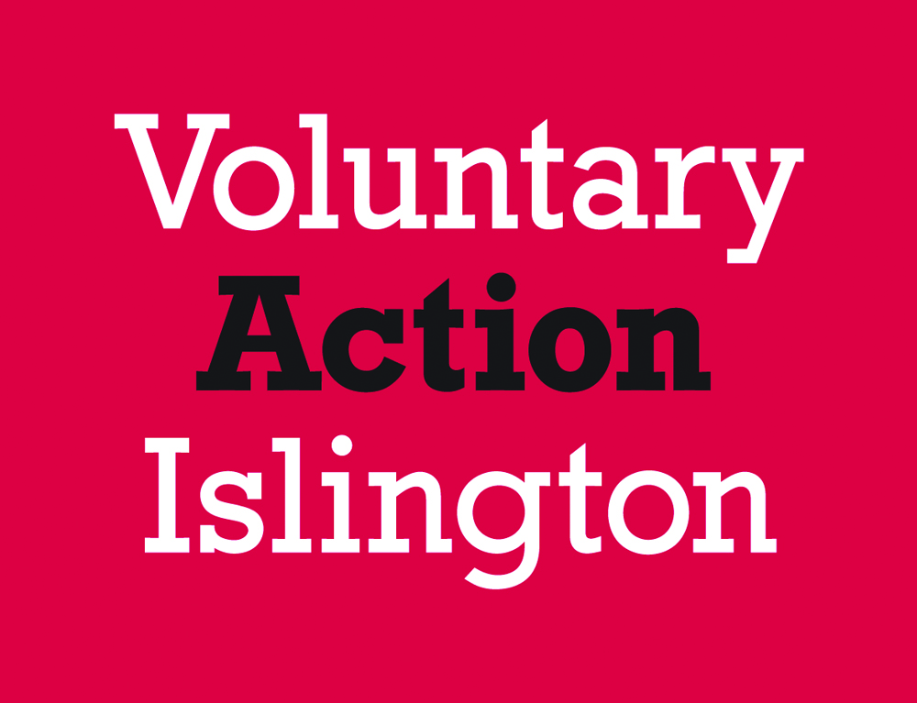

A number of local organisations are working in partnership with Voluntary Action Islington on this project, including the Islington Refugee Forum, the Islington Faiths Forum, the Islington Play Association, The Islington Childcare Trust, the Octopus Community Centre Network, Homes for Islington and Islington Council.
3. SAMPLE FORM - NOT TO BE USED
Form 76
Form for Certifying a Place of Meeting for Religious Worship under the
Places of Worship Registration Act 1985

DIRECTIONS  for filling up this Form.  (a) Insert the distinctive name by which the place of worship is known.  (b) State the precise address of the building. If it bears a street number this should be stated. If only part of a building is to be certified, state this clearly, eg "room on ground floor marked Main Hall" or as the case may be.  (c) If the building has been previously used as a place of worship, add the words "as heretofore".  (d) Here insert the religious denomination of, or religious appellation adopted by, the persons on whose behalf the building is certified. This should be the name of the  central organisation with which the congregation is associated, but if there is no such organisation and the congregation do not describe themselves by any distinctive appellation the description "Christians not otherwise designated" may be used. If the worshippers decline to  describe themselves by any distinctive appellation, the words "calling themselves" may be erased and the words  "who object to be designated by any distinctive religious  appellation" inserted.  (e) Insert the word "Minister," "Proprietor," "A Trustee," "Occupier," or such other words as will clearly show the connection subsisting between the person certifying and the place of worship. | TO THE REGISTRAR GENERAL  _________________  I, the undersigned (name), ...........................................................  (rank or profession) .......................................................................  Of (address)...................................................................................  DO HEREBY, under and by virtue of the Place of Worship Registration Act, 1855, CERTIFY that a certain Building know by the name of (a)  ……………………………………………………………………………..  situated at (b)....................................................................................  …………………………………………………………in the..................  Non-Metropolitan County / Metropolitan District / London Borough of  .........................................................................................................  in the sub-district of .........................................................................  in the Registration district of ............................................................  is intended to be used..........................................(c) and  will accordingly be forthwith used as a place of meeting for religious worship by a congregation or assembly of persons calling themselves (d)  ........................................................................................................  ……………………………………………………………………………  And I request that this Certificate may be recorded in the General Register Office pursuant to the said Act. Dated this ......................  Day of.............................................................................................  (Signature of the .........................................  person Certifying)  (e).................................................................................................  of the place of meeting above described  __________________________________________  NB - When the building to be certified as a place of meeting for religious worship is intended to be used in lieu of a building previously certified to, and recorded by the Register General, a form of "Notice of disuse" of the latter building should also be filled up and forwarded to the General Register Office, to ensure cancellation of the original certificate and record in accordance with section 6 of the Act.

